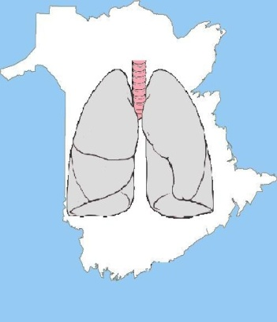
New Brunswick Association of Respiratory Therapists

Employment Verification Form

Section 1
This section must be completed by the applicant and forwarded to the place of employment in the jurisdiction(s) in which you have been practicing as a Respiratory Therapist (or in a related field) over the past five years.
I, _________________________ ___________ hereby authorize ________________________________________
^{PRINT NAME} ^{LICENSE NUMBER} ^{EMPLOYER NAME}
to provide the information requested below and any additional information requested by the New Brunswick Association of Respiratory Therapists (NBART) in order to process my application for registration.
_________________________________________ ___________________________________ APPLICANT’S SIGNATURE DATE
Section 2
This section must be completed by the employer (preferably by the applicant’s immediate supervisor) and forwarded directly to the NBART.

This is to certify that __________________________________________________________________________
^{APPLICANT’S NAME}

is / was employed by _________________________________________________________________________
^{NAME OF EMPLOYER}

as _________________________________________________________________________________________
^{POSITION TITLE}
Date of Hire: __________________________ Last Date of Employment (if applicable): _______________________________
- Has the applicant been disciplined, suspended, required to resign, terminated or subjected to similar action in respect to employment or a contract of service? Yes No
- Are you aware of any other information (e.g., court or tribunal findings, complaints) about the applicant's competence, conduct, or physical/mental capacity that could reasonably affect the applicant's ability to function as a Respiratory Therapist? Yes No
*If the answer is “Yes”, provide additional information, including a description of the matter, relevant findings and any resulting orders/penalties.
______________________________________ ______________________________________ NAME OF AUTHORIZED FACILITY REPRESENTATIVE TITLE
______________________________________ ______________________________________ PHONE NUMER EMAIL ADDRESS
______________________________________ ______________________________________ ^{SIGNATURE} ^{DATE}

